Final report
based on the research of psychophysiological reactions of respondents to
the Apple Watch use

September 2015

eMerite, s.r.o., member of the group FG Forrest, in cooperation with IPSOS, s.r.o.
Pernerova 635/57, 186 00 Praha 8, tel.: 225 377 892, e-mail: info@emerite.cz
www.emerite.cz, www.twitter.com/emerite

Table of contents

Basic information: What and how we measured 2
Photo documentation: How we measured 4
Summary of key information: what we learned 5
Attractiveness of watch wristbands based on EEG and Eye Tracking 6
ATTENTION caused by Apple Watch functions 7
EMOTIONS causedby Apple Watch functions 8
Effect of Apple Watch compared to benchmarks (1/2) 9
Effect of Apple Watch compared to benchmarks (2/2) 10

Basic information: what and how we measured

Research target | Main target of the neuro-marketing research eMerite was to find out the level of focus and emotional reactions (positive or negative) caused by use of the Apple Watch product. At the same time was researched the unaware emotional effect of various design versions of the watch or their wristbands.
Monitored indicators | Electroencephalography (EEG) of the brain is recording bioelectrical activities of the brain on the frontal lobe and prefrontal lobe of left and right hemispheres. These are responsible for decision-making, thinking and expressing of human emotions. Level of attention and level of emotional reaction of the person to various inputs can be found with use of EEG. Form of brainwaves BETA and SMR give evidence of the level of attention stimulated by the tested input, form of Gama brainwaves gives the evidence of polarity of caused emotions.  Eye Tracking – the eye trajectory of respondents, i.e. what attracted their attention at which moment, was monitored with use of the static eye camera.
Data of respondents | In total 20 persons (13 men and 7 women) participated in the research based on the selection made from panel of respondents of IPSOs agency.  They were a representative sample of users of modern mobile communications with positive approach to the so called wearables.  From each respondent we obtained with use of EEG 192 statistic data per second, in total 4,608 million data from all respondents for the whole research in total.
Research date and place | Data collection was performed on 13 and 14 August 2015 in the premises of IPSOS agency, Na příkopě 22, Praha 1 – Nové Město.

Photo documentation: how we measured
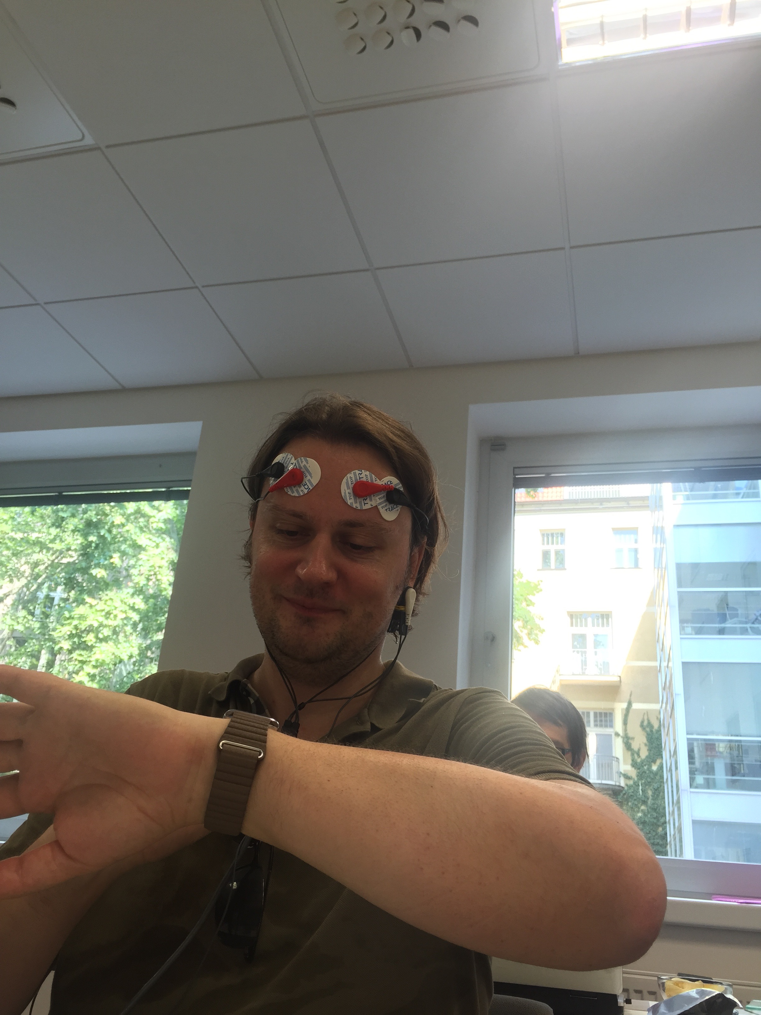

Summary of key information: what we discovered
 | Choice of design wristbands | Unusual look of Apple Watch wristbands is causing higher emotional reactions than conventional wristbands similar to other watch. Therefore it confirms the competition advantage that the Apple Watch owners may themselves select the look of their watch.
 | Remote camera release | Camera control from the mobile phone of the watch caused very strong positive emotions. Also due to the fact that the user may watch himself on the display (take a selfie). It would be doubtless the plentifully used function related to increased popularity of the selfie stick.
 | Calls making is not subjectively attractive, but the reality would impress | Even though respondents expressed their doubt about making phone calls from the Apple Watch, they showed rather strong positive emotions when the incoming call vibrated on their wrist. Higher than upon received SMS or displayed reminder of the event of task.
 | Siri popularity is obstructed by need of English | Unsuccessful attempts for voice communication with the voice assistant Siri caused – naturally- negative emotions but once respondents handled the English pronunciation and Siri met their instruction, they proved very strong positive emotional reactions.
 | Use of Apple Watch is transforming sceptics into sympathizers | Respondents experienced during the 59 % of the testing time positive emotions and negative once during 41 %. Before they tested the watch, they expressed scepticism, but once they had positive personal experience with tested functions, they experienced positive emotions. Transformation of the original scepticism into positive „final emotions“ (even enthusiasm in quarter of respondents) is very desirable and valuable phenomenon, not common to majority of products.
 | Repeating reduced focus and emotions | During repeated testing of the same function (Siri communication, event vibration on the watch etc.) the emotional reactions and focus got slightly reduced. I.e. the tested function was not so surprising for respondents as for the first time, but values remained still on above-standard levels.
 | The less attractive wristband taken from Apple web | Light Brown Leather Loop, which in the eMerite NEURO research with Eye Tracking attracted the least, was removed by Apple in September 2015 from the web. No doubts based on their own research...

Attractiveness of watch wristbands based on EEG and Eye Tracking
Based on the monitoring of eye trajectory of respondents with use of static eye camera (Eye Tracking method) in combination with brain EEG we introduce data of attention and emotions caused by individual Apple Watch wristbands.
Watch are arranged in the table from the left to the right in the order shown to respondents on the monitor. Proportional values indicated increase or drop of the attention and emotions compared to idle condition of respondents (= 0 %).
Apple Watch wristband | Black Classic Buckle | Blue Sport Band | Light Brown  Leather Loop | Milanese Loop | Soft Pink  Modern Buckle | Link Bracelet
Points of interests by Eye Tracking | 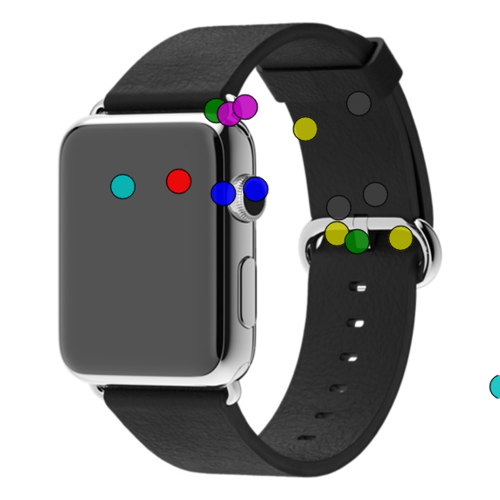 | 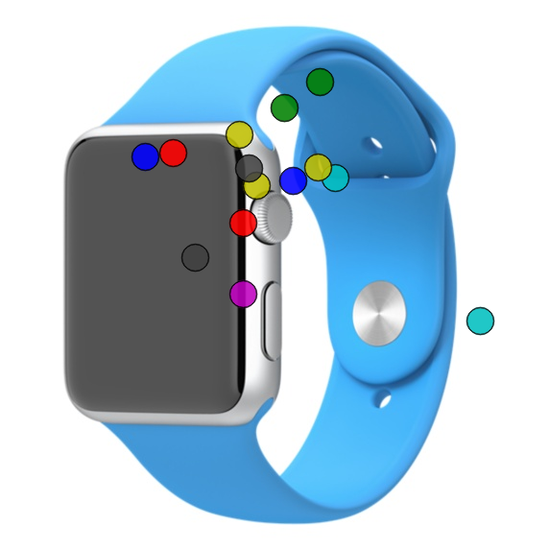 | 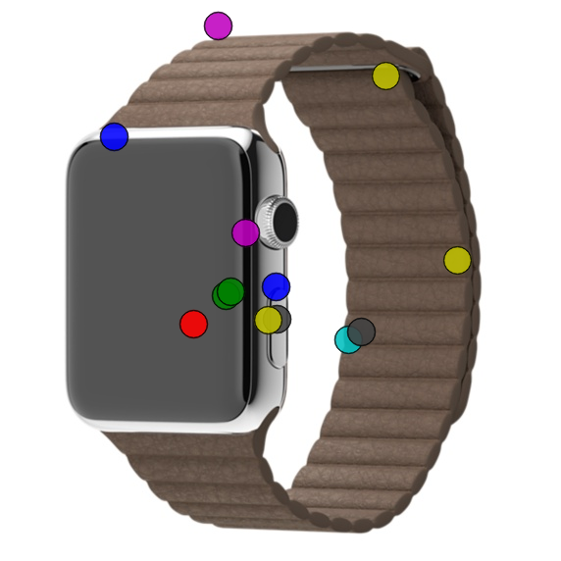 | 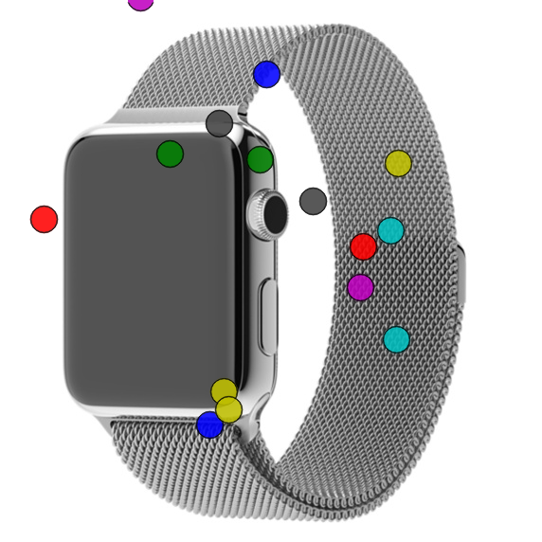 | 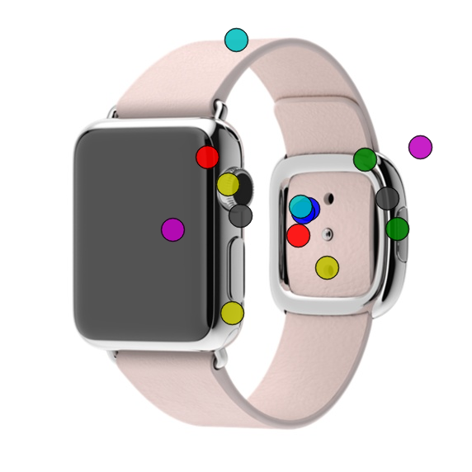 | 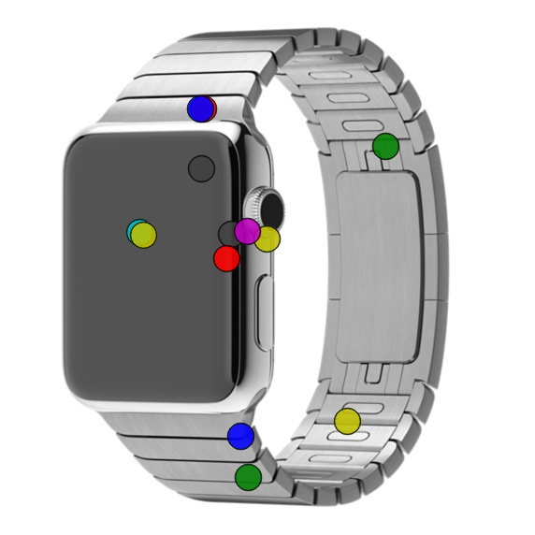
Share of 3sec display | 1st longest watching  (47 % of exposure) | 2nd longest watching  (43 % of exposure) | 3rd shortest watching  (34 % of exposure) | 1st shortest watching  (30 % of exposure) | 3rd longest watching  (36 % of exposure) | 2nd shortest watching  (32 % of exposure)
FOCUS (average) | 7,4 % | 13,1 % | -0,5 % | 8,9 % | 12,8 % | 3,3 %
EMOTIONS  (average) | -2,9 % | +11,0 % | +3,9 % | +4,2 % | +12,6 % | +5,7 %
 | (negative for 76% respondents) | (positive for 72% respondents) | (positive for 60% respondents) | (positive for 68% respondents) | (positive for 62% respondents) | (positive for 54% respondents)
Notes | Negative emotions were caused probably by "ordinary" dark look . | Highest focus with  2nd highest positive emotions | Lowest measured focus. Wristband feels ordinary.  Apple took it from the web In September 2015 | Positively apprehended type because of spliced metal wristband. | Unconventional pink wristband attracted highest focus and emotions regardless the sex of respondents. | Luxurious metal wristband which might also look cold.

ATTENTION caused by Apple Watch functions
During user testing of Apple Watch the brain activity (EEG) of respondents was monitored. Analysis of the brainwave BETA and SRM form then demonstrated level of the attention of respondents caused by the following functions of the watch (introduced in the order as tested): received SMS, notification of two reminders, incoming call, remote photo taking, use of the self-timer for picture taking, giving three voice tasks to the Siri assistant.

Proportional values indicated level of emotional relations compared to the idle condition of respondents (= 0 %).

Five tested functions are arranged in the table from the top-down from the highest caused attention to the lowest one.

Order | Function of the watch | ATTENTION | Notes
1. | Incoming call | 54,7 % | Highest level of attention caused the incoming call, when respondents could unexpectedly „make a watch call“.
2. | Camera control | 53,9 % | Remote picture taking by the release on the watch caused higher attention than activation of the self-timer. And respondents took with higher concern selfies with front camera than pictures of objects in front of the main iPhone camera.
3. | Siri the assistant | 43,4 % | Addressing the voice assistant Siri caused relatively higher attention as this function requires higher concentration and mainly very good pronunciation of the instruction in English.
4. | Incoming SMS | 32,0 % | Notification of the incoming SMS was accompanied with sound and vibration of the watch, and as it is rather expected function it did not surprise respondents remarkably.
5. | Event, reminder | 31,1 % | Similarly to incoming SMS is functioning the reminder of event or task, so no stronger increase of the attention was detected compared to above stated functions. Value of the focus was almost identical with the one for SMS.

EMOTIONS caused by Apple Watch functions
Analysis of Gama brainwaves proved level of emotional reactions experienced by respondents during controlling the following watch functions (in the order as tested): incoming SMS, 2 reminders, incoming call, remote picture taking, use of the self-timer for picture taking, giving three instructions to the voice assistant Siri.

Proportional values in the table indicate level of emotional reactions compared to the idle conditions of respondents (= 0 %).

Five tested functions are listed in the table top-down from most positive caused emotions up to least positive. No expressly negative emotions were shown by respondents.

Order | Function of the watch | EMOTIONS | Notes
1. | Incoming call | +93,5 % | Respondents experienced the incoming call very positively, including watch ringing. Although they had subjectively restrained approach to „calling from the watch“, their later unaware concern was very high.
2. | Siri the assistant | +75,4 % | Giving the instruction to voice assistant caused first negative emotions as respondents failed to communicate with Siri in English. However once they handled proper pronunciation and Siri fulfilled the instruction (i.e. displayed the required content or switched on the song on the phone) we recorded highly positive emotions. Transformation of originally negative emotions into positive co called final emotions thanks to positive user experience is a very important feature of the Apple Watch.
3. | Camera control | +72,1 % | Remote camera control of iPhone from the Apple Watch proves higher positive emotions also due to possibility to make a selfie. Positive emotions got reduced with choice of the self -timer.
4. | Event, reminder | +47,9% | Reminder caused lower emotional reaction compared to other functions. For example camera or Siri functions „drag the user more in the game“.
5. | Incoming SMS | +39,2 % | Demonstrated similarly to the reminder function (vibration, sound signal) caused lower emotions however still positive, similarly to reminders.

Effect of the Apple Watch compared to benchmarks (1/2)
Measured brain EEG values were compared with benchmarks, i.e. with standard levels of the attention and emotional reactions. These benchmarks are on a long-term basis compiled from results of all researches performed by eMerite NEURO. Benchmarks show usual level of attention and emotions caused by presentation of certain marketing input („good standard“). I.e. values higher/lower than benchmark give evidence of unusually high/low concern of respondents in the tested input, whether it is a TV advertisement, product wrapping or the actual product.

Polarity of emotions caused by marketing stimulation

INDICATOR | BENCHMARK | VALUES MEASURED DURING USE OF  APPLE WATCH
Share of positive emotions | 60 % | 59 %
Share of negative emotions | 40 % | 41 %
Average value of emotional reactions | +13,2 % | +42,7 %

- Usual ratio (benchmark) of positive and negative emotions caused by marketing stimulants is usually 60:40. Testing of Apple Watch brought equal values 59 % to 41 % (see second and third row), therefore in this indicator they do not differ from other products.
- Per contra the average level of emotional reaction during testing of the Apple Watch functions (fourth row on the right) reached +42,7 %, i.e. triple of the benchmark. It means that Apple Watch cause rather strong emotional reactions, incomparable with any other marketing inputs which had been so far tested by the service eMerite NEURO.

Effect of the Apple Watch compared to benchmarks (2/2)
Benchmarks of attention and emotions caused by marketing stimulant

INDICATOR | BENCHMARK | VALUES MEASURED DURING USE OF  APPLE WATCH
Attention level | 8,6 % | 47,8 %
Level of negative emotions | -8,2 % | -34,6 %
Level of positive emotions | +14,1 % | +47,1 %

- Generally all values measured during user testing of Apple Watch can be assessed as very high compared to the benchmarks.
- Tested functions caused exceptionally high positive emotions in respondents: +47,1 % compared to the benchmark (+14,1 %), i.e. about triple the standard. User experience with Apple Watch je incomparable with earlier tested marketing inputs from the aspect of positive perception.
- Similarly, it is about the attention level, which reached more than five times of the benchmark value (47,8 % to usual 8,6 %).

